Assignment 1

1. Explain in detail the Strategic business objectives of Information Systems. (Answer in 1 to 2 pages)

Information systems are a necessity of doing business in the 21st century. It is essential for conducting day-to-day business in the United States and most other advanced countries, as well as achieving strategic business objectives. Moreover, information systems enable organizations to thrive and survive during turbulent times. As a result, organizations invest in information systems to achieve six strategic business objectives: (1) achieve operational excellence; (2) create new products, services, and business models; (3) improve customer and supplier intimacy; (4) improve decision-making; (5) establish competitive advantage; and (6) survive.

There's a developing interdependency between a firm’s capacity to utilize data innovation and its ability to actualize corporate procedures and accomplish corporate objectives. What a trade would like to do in five a long time frequently depends on what its frameworks will be able to do. Expanding showcase share, getting to be the high-quality or low-cost maker, developing new items, and expanding representative efficiency depend increasingly on the sorts and quality of information systems within the organization. The more you get it almost this relationship, the more valuable you'll be as a manager.

Operational Excellence

Businesses continuously seek to improve the efficiency of their operations in order to achieve higher profitability. Information systems and technologies are some of the most important tools available to managers for achieving higher levels of efficiency and productivity in business operations, especially when coupled with changes in business practices and management behavior.

Walmart uses a variety of information systems to enable significant business relationships with its suppliers and customers. For instance, Walmart uses its Retail Link systems to achieve digital integration with its suppliers to facilitate inventory management. When a customer purchases an item, the information is automatically shared with the appropriate supplier. By enabling the suppliers to manage inventory, Walmart has significantly improved the inventory management process while reducing costs that can be passed on to consumers.

New Products, Services, and Business Models  
Entrepreneurs and organizations are increasingly using information technologies to create new products and services as well as new business models. Information systems and technologies are a major enabling tool for firms. concept of business models The concept of a business model is to describe how an organization produces, delivers and sells a product or service.

In today’s on-demand economy, organizations are increasingly using innovative technologies to create new on-demand business models to provide real-time fulfillment of products and services. For example, Airbnb’s housing rental app enables the organization to automate the entire process from booking accommodations to paying for the service.

Customer and Supplier Intimacy

Intimacy between the business and either its customers or its suppliers refers to a strengthening of the bond between the two parties. Information systems can be used to increase the bond between the business and both its customers and suppliers. For example, using information systems, Amazon has achieved high customer intimacy by allowing one-click checkout, recommending relevant products to customers, and allowing customers to maintain a wish list of products. When a business really knows its customers, and serves them well, the custom- ers generally respond by returning and purchasing more. This raises revenues and profits. Likewise with suppliers: the more a business engages its suppliers, the better the suppliers can provide vital inputs. This lowers costs. How to really know your customers, or suppliers, is a central problem for businesses with millions of offline and online customers.

Improved Decision Making

Information systems give managers the tools to facilitate data-driven decision-making. For example, a manager can look at the data about what products are selling and make a better decision about what products need to be reordered and what quantity of product should be reordered. In addition, using a spreadsheet tool such as Microsoft Excel, a manager can examine different pricing scenarios to find the optimal price for a product.

Numerous trade supervisors work in an data haze bank, never truly having the correct information at the correct time to form an educated choice. Instep, supervisors depend on figures, best surmises, and luckiness. The result is over- or underproduction of products and administrations, misallocation of assets, and destitute reaction times. These destitute results raise costs and lose clients. Within the past decade, data frameworks and innovations have made it conceivable for supervisors to utilize real-time data from the commercial center when making choices.

Competitive Advantage

When organizations achieve one or more of the aforementioned strategic business objectives—(1) operational excellence; (2) new products, services, and business models; (3) customer and supplier intimacy; and (4) improved decision-making—they are more than likely to have achieved a competitive advantage. Doing things better than your competitors, charging less for superior products, and responding to customers and suppliers in real time all add up to higher sales and higher profits that your competitors cannot match. Apple Inc., Walmart, and UPS, are industry leaders because they know how to use information systems for this purpose.

Survival

Businesses today incorporate information systems into their daily activities as a necessity for doing business. Sometimes these necessities are driven by consumer preferences and demand. For example, using the Internet and mobile apps has become a business necessity and a source of competitive advantage. As a result, organizations that are not using innovative technologies, such as digital payment systems and mobile apps, may be at a competitive disadvantage in certain markets.

For instance, after Citibank introduced the first automated teller machines (ATMs) in the New York region in 1977 to attract customers through higher service levels, its competitors rushed to provide ATMs to their customers to keep up with Citibank.

Resources:

<https://courses.worldcampus.psu.edu>

Kenneth C. Laudon, Jane P. Laudon. Management Information Systems Managing the Digital Firm

1. Draw a neat diagram of the functions of an Information System and Explain in detail the five components of an Information System. (Answer in 1 to 2 pages)

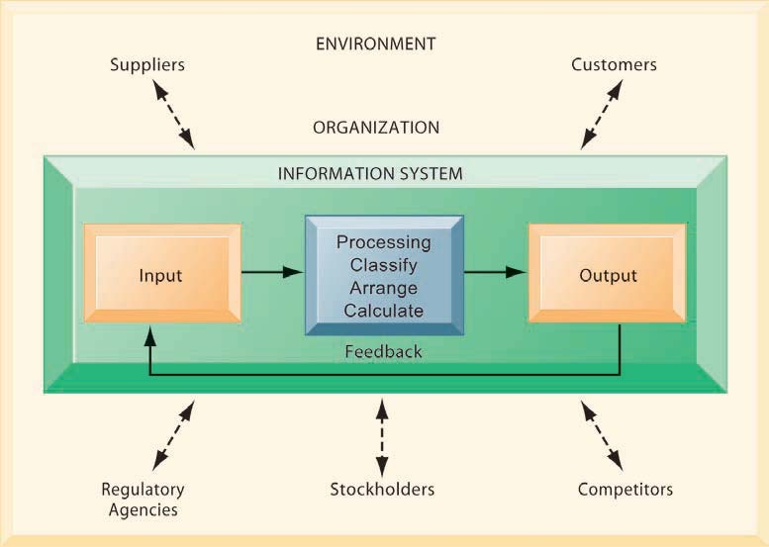

An information system contains information about an organization and its surrounding environment. Three basic activities—input, processing, and output—produce the information organizations need. Feedback is output returned to appropriate people or activities in the organization to evaluate and refine the input. Environmental actors, such as customers, suppliers, competitors, stockholders, and regulatory agencies, interact with the organization and its information systems.

An Information system is a combination of hardware and software and telecommunication networks that people build to collect, create and distribute useful data, typically in an organization. It defines the flow of information within the system. The objective of an information system is to provide appropriate information to the user, to gather the data, process the data and communicate information to the user of the system.

1. Computer Hardware:

This is the physical technology that works with information. Hardware can be as small as a [smartphone](https://www.britannica.com/technology/smartphone) that fits in a pocket or as large as a [supercomputer](https://www.britannica.com/technology/supercomputer) that fills a building. Hardware also includes the [peripheral devices](https://www.britannica.com/technology/input-output-device) that work with computers, such as keyboards, external disk drives, and routers. With the rise of the [Internet of Things](https://www.britannica.com/science/Internet-of-Things), in which anything from home appliances to cars to clothes will be able to receive and transmit data, sensors that interact with computers are permeating the human environment.

2. Computer Software:

The hardware needs to know what to do, and that is the role of [software](https://www.britannica.com/technology/software). Software can be divided into two types: system software and application software. The primary piece of system software is the [operating system](https://www.britannica.com/technology/operating-system), such as [Windows](https://www.britannica.com/technology/Microsoft-Windows) or iOS, which manages the hardware’s operation. Application software is designed for specific tasks, such as handling a spreadsheet, creating a document, or designing a [Web](https://www.britannica.com/topic/World-Wide-Web) page.

Software development involves various stages, including design, coding, testing, and maintenance. It is continuously evolving, with updates and new versions released to improve functionality, security, and performance.

The programs/ application program used to control and coordinate the hardware components. It is used for analyzing and processing of the data. These programs include a set of instruction used for processing information.

3. Databases: This component is where the “material” that the other components work with resides.

A [database](https://www.britannica.com/technology/database) is a place where data is collected and from which it can be retrieved by querying it using one or more specific criteria. A data warehouse contains all of the data in whatever form that an organization needs. Databases and data warehouses have assumed even greater importance in information systems with the emergence of “big data,” a term for the truly massive amounts of data that can be collected and analyzed.

Data are the raw facts and figures that are unorganized that are later processed to generate information. Software are used for organizing and serving data to the user, managing physical storage of media and virtual resources. As the hardware can’t work without software the same as software needs data for processing. Data are managed using Database management system.

Database software is used for efficient access for required data, and to manage knowledge bases.

4. Network:

This component connects the hardware together to form a network. Connections can be through wires, such as Ethernet cables or [fibre optics](https://www.britannica.com/science/fiber-optics), or wireless, such as through [Wi-Fi](https://www.britannica.com/technology/Wi-Fi). A network can be designed to tie together computers in a specific area, such as an office or a school, through a local area network (LAN). If computers are more dispersed, the network is called a wide area network (WAN). The [Internet](https://www.britannica.com/technology/Internet) itself can be considered a network of networks.

* Networks resources refer to the telecommunication networks like the intranet, extranet and the internet.
* These resources facilitate the flow of information in the organization.
* Networks consists of both the physical devices such as networks cards, routers, hubs and cables and software such as operating systems, web servers, data servers and application servers.
* Telecommunications networks consist of computers, communications processors, and other devices interconnected by communications media and controlled by software.
* Networks include communication media, and Network Support.

5. Human Resources:

The final, and possibly most important, component of information systems is the human element: the people that are needed to run the system and the procedures they follow so that the knowledge in the huge databases and data warehouses can be turned into learning that can interpret what has happened in the past and guide future action. It is associated with the manpower required to run and manage the system. People are the end user of the information system, end-user use information produced for their own purpose, the main purpose of the information system is to benefit the end user. The end user can be accountants, engineers, salespersons, customers, clerks, or managers etc. People are also responsible to develop and operate information systems. They include systems analysts, computer operators, programmers, and other clerical IS personnel, and managerial techniques.

<https://www.geeksforgeeks.org/components-of-information-system/>

<https://www.britannica.com/story/5-components-of-information-systems>

Kenneth C. Laudon, Jane P. Laudon. Management Information Systems Managing the Digital Firm

1. **What** are Enterprise Systems? **Draw** a neat diagram to show how enterprise systems work

Enterprise systems, also known as enterprise resource planning (ERP) systems, which are based on a suite of integrated software modules and a common central database. The database collects data from many different divisions and departments in a firm, and from a large number of key business processes in manufacturing and production, finance and account- ing, sales and marketing, and human resources, making the data available for applications that support nearly all of an organization’s internal business activities. When new information is entered by one process, the information is made immediately available to other business processes

Enterprise systems (ES) are mainly large scale application programming packages that bolster business processes, data streams, reporting, and data analytics in complex associations. While Enterprise System are by and large packaged enterprise application software (PEAS) frameworks they can also be, specially developed systems made to bolster a particular organization's requirements.

Small scale organizations implement the framework of enterprise system to pick up far reaching access to business learning, increase worker profitability and minimize the duplication of organization information. Enterprise systems might likewise empower a business to diminish the expense of information technology and minimize the manual input of information. These enterprise system characteristics offer specific advantages, for example, the backing of cooperation, an enhanced response to the marketplace, expanded work quality and increased worker collaboration and effectiveness.

An enterprise system framework permits organizations to coordinate business procedures, for example, sales, deliveries and accounts receivable, by sharing data crosswise over business capacities and employee hierarchy systems. Enterprise systems can supplant different autonomous frameworks that might connect with different frameworks and that procedure information to bolster specific business capacities or procedures. For instance, enterprise resource planning supports the whole sales process that incorporates pre-sales exercises, sales requests, stock sourcing, deliveries, charging and customer payments.

Examples of enterprise systems are:

• Enterprise resource planning or ERP systems

• Supply chain management

• Customer relationship management systems.

page371image25758144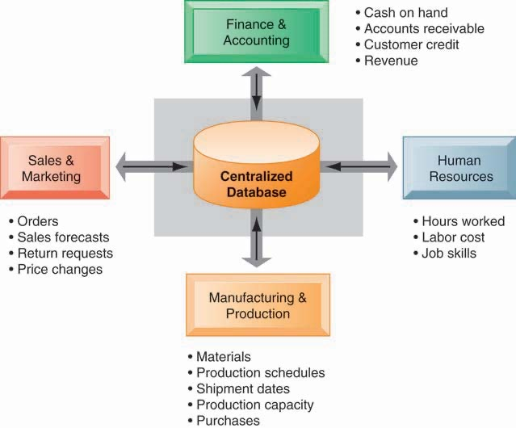

Enterprise systems feature a set of integrated software modules and a central database that enables data to be shared by many different business processes and functional areas throughout the enterprise.

https://www.mbaskool.com/business-concepts/it-and-systems/14316-enterprise-system.html

Kenneth C. Laudon, Jane P. Laudon. Management Information Systems Managing the Digital Firm

**b. Explain** in detail the **Supply Chain** and **Supply Chain Management Systems**. **Draw** a neat diagram showing the **BULLWHIP** effect.

A firm’s supply chain is a network of organizations and business processes for procuring raw materials, transforming these materials into intermediate and finished products, and distributing the finished products to customers. A supply chain links everything from the delivery of source materials from the supplier to the manufacturer through to its eventual delivery to the end user.

Materials, information, and payments flow through the supply chain in both directions. Goods start out as raw materials and, as they move through the supply chain, are transformed into intermediate products (also referred to as components or parts), and finally, into finished products. The finished products are shipped to distribution centers and from there to retailers and customers. Returned items flow in the reverse direction from the buyer back to the seller. The supply chain segment involved with getting the finished product from the manufacturer to the consumer is known as the distribution channel.

SUPPLY CHAIN MANAGEMENT SOFTWARE

Supply chain software is classified as either software to help businesses plan their supply chains (supply chain planning) or software to help them execute the supply chain steps (supply chain execution). Supply chain planning systems enable the firm to model its existing supply chain, generate demand forecasts for products, and develop optimal sourcing and manufacturing plans. Such systems help companies make better decisions such as determining how much of a specific product to manufacture in a given time period; establishing inventory levels for raw materials, intermediate products, and finished goods; determining where to store finished goods; and identifying the transportation mode to use for product delivery. The three main flows of the supply chain are the product flow, the information flow and the finances flow. These occur across three main stages: strategy, planning and operation. SCM involves coordinating and integrating these flows both within and among companies.

Supply chain execution systems manage the flow of products through distribution centers and warehouses to ensure that products are delivered to the right locations in the most efficient manner. They track the physical status of goods, the management of materials, warehouse and transportation opera- tions, and financial information involving all parties.

page376image25758352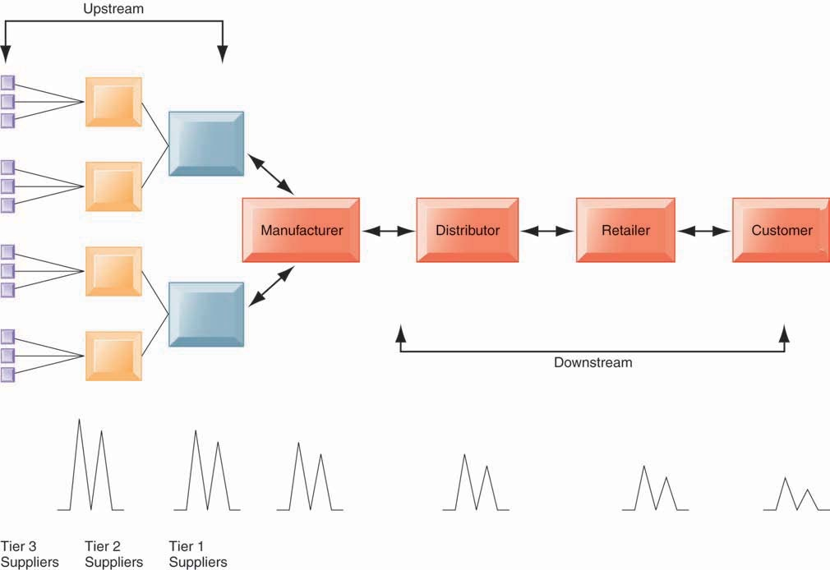

Inaccurate information can cause minor fluctuations in demand for a product to be amplified as one moves further back in the supply chain. Minor fluctuations in retail sales for a product can create excess inventory for distributors, manufacturers, and suppliers.

<https://www.techtarget.com/whatis/definition/supply-chain>

Kenneth C. Laudon, Jane P. Laudon. Management Information Systems Managing the Digital Firm